CLOTHING E-COMMERCE PLATFORM
(Website)


Session 2022-2026

Submitted by:
SURRAYA IBAD
Reg: WUS/22-779
Enrolment: SE-BS(22FA)-15

Supervised By:
MA’AM NIMRA BARI
Head Department of Computer Science, WUS

DEPARTMENT OF SOFTWARE ENGINEERING
WOMEN UNIVERSITY, SWABI
2024

CLOTHING E-COMMERCE PLATFORM
(Website)


This project proposal is submitted to the Department of Computer Science, Women University, Swabi, as part of the requirements for a Bachelor's degree in Software Engineering (BSSE).
19 November 2025

Author(s):
_______________________
SURRAYA IBAD,
Bachelors of Software Engineering

_____________________
Supervisor
MA’AM NIMRA BARI
Head of Department of Computer Science,
Women University Swabi, KP

Head Of Department
Department of Computer Science, WUS

Table of Contents:
1. Introduction: 4
2. Project Overview 4
3. Objectives: 4
4. Advantages: 4
5. Limitation: 4
6. Development Tools 4
7. PROCESS MODEL 5
8. Existing System 5
9. System Design (UML & DFDs ) 5
10. Zero Level DFD Diagram 8
11. First Level DFD Diagram 8
12. ERD Diagram 10
13. Use case diagram 12
14. Gantt Chart 14
15. REFERENCES 14

Table of figure:
Figure 1 Incremental model 5
Figure 2 UML Diagram 6
Figure 3 Login Activity Diagram 7
Figure 4 Zero level DFD Diagram 8
Figure 5 First level DFD Diagram 10
Figure 6 ERD Diagram 12
Figure 7 Use Case Diagram 13
Figure 8 Gantt Chart 14

1. Introduction:
- Fashion industry is shifting rapidly to digital platforms.
- Customers expect smooth, interactive, and personalized shopping experiences.
- Many small clothing retailers still rely on outdated or manual systems.
- This project builds a MERN-based e-commerce platform — modern, scalable, and easy to use for online clothing and fabric sales.

2. Project Overview
The project is a full-stack E-commerce Web Application. It consists of two major modules:
- Customer Side: Includes user registration/login, product catalog with search and filter, product detail pages with color/size selection, a persistent shopping cart, a secure checkout process, and order history.
- Admin Side: Provides a secure dashboard for managing product inventory (CRUD operations), categorizing products, processing customer orders, and viewing sales analytics.

3. Objectives:
• Develop a modern clothing e-commerce website using the MERN stack.
• Create a responsive and user-friendly interface for easy shopping on all devices.
• Provide a secure login and authentication system for customers and admins.
• Enable product management (add, update, delete) through an admin dashboard.
• Implement cart and checkout features for smooth order processing.
• Host the website on cloud platforms for high performance and reliability.

4. Advantages:
- Easy Shopping: Simple, fast website that works on any device.
- Safe & Secure: Protected user accounts and secure logins.
- Easy Management: All-in-one dashboard for managing products and orders.
- Always Available: Reliable cloud hosting that grows with your business.

5. Limitation:
- Payment: Payment processing will be simulated (not real payments)
- Limited Products: Limited number of products for demonstration
- Features: Basic features only (no advanced analytics)

6. Development Tools
Category | Technology/Tool
Frontend | React (Vite), Tailwind CSS, Context API
Backend | Node.js, Express.js
Database | MongoDB Atlas (Cloud)
Authentication | JWT (JSON Web Tokens), bcrypt
File Storage | Multer, Cloudinary
Deployment | Vercel/Netlify (Frontend), Render (Backend)

7. Process Model
The Incremental Model will be used with the following phases:
- Setup
- Authentication
- Product CRUD
- Cart & Checkout
- Admin Dashboard
- Testing & Deployment
Each phase will undergo development, testing, and feedback cycles.
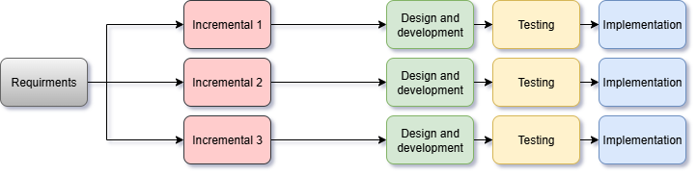
Figure 1: Incremental Model

8. Existing System
Most traditional clothing stores rely on manual sales or basic catalog websites without real-time previews or efficient order management. The proposed system provides an interactive and scalable e-commerce solution.

9. System Design (UML & DFDs)

Features of the Activity UML Diagram of E Commerce Website: 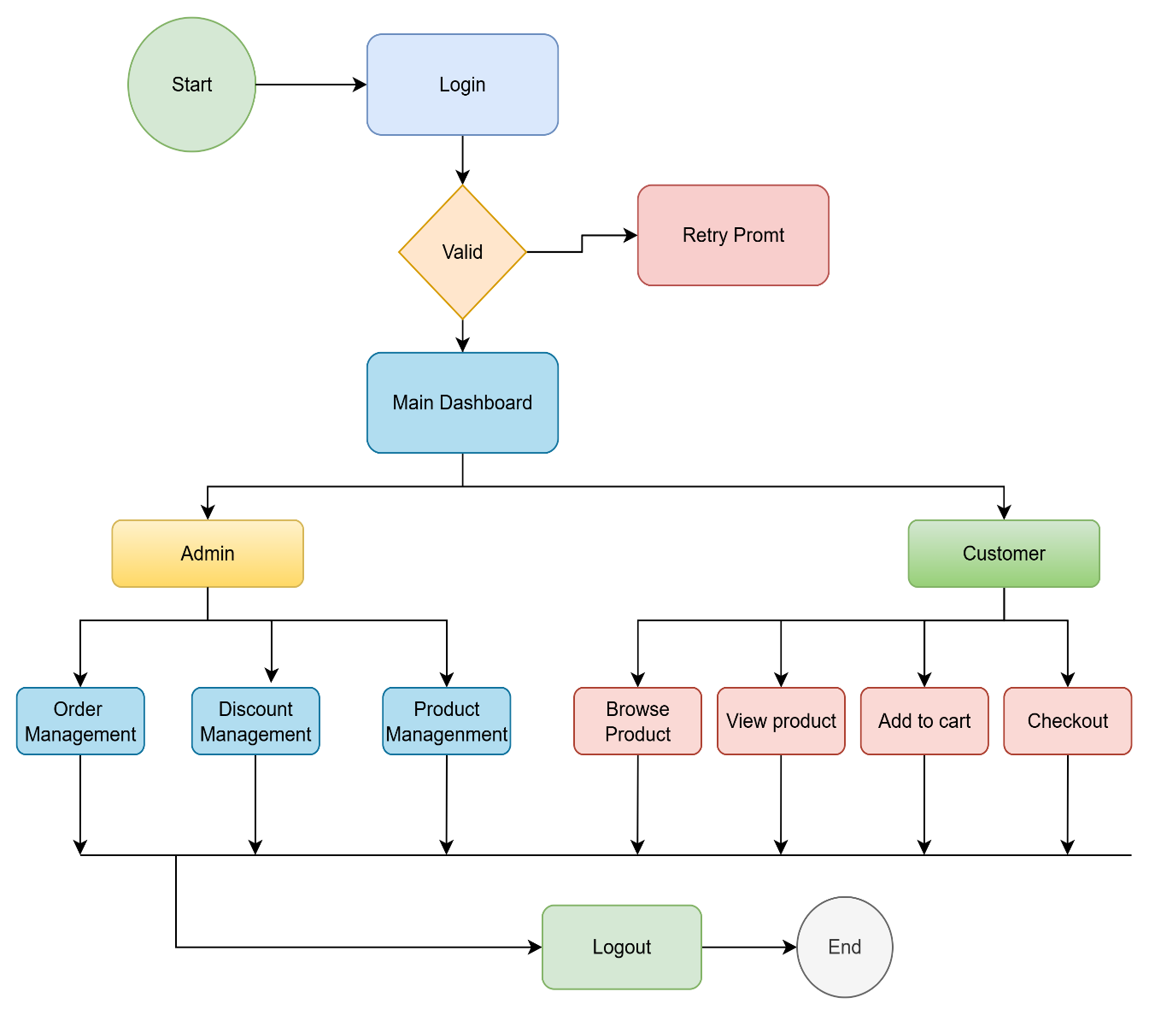
Figure 2: UML Diagram

2.Login Activity Diagram of E Commerce Website:

An Activity Diagram in UML (Unified Modeling Language)
is used to represent the flow of activities or actions in a system. In the context of a Login process, the Login Activity Diagram represents the series of steps a user takes to authenticate themselves into a system, such as Clothing E-commerce Website.
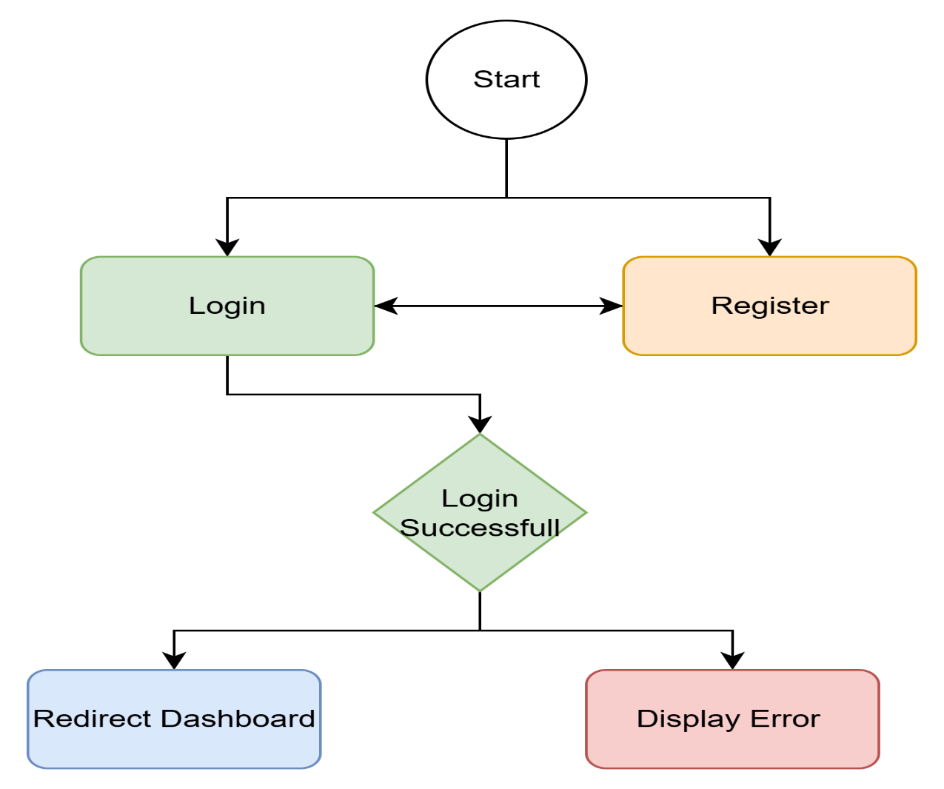

Figure 3: Login Activitity Diagram

10. Zero level DFD Diagram :
Main Process: E-Commerce System
External Entities:
- Customer → Login, Order, Payment
- Admin → Manage Products & Reports
- Inventory System → Stock update
- Payment Gateway → Payment authentication
System sends:
- Order confirmation
- Reports
- Inventory updates
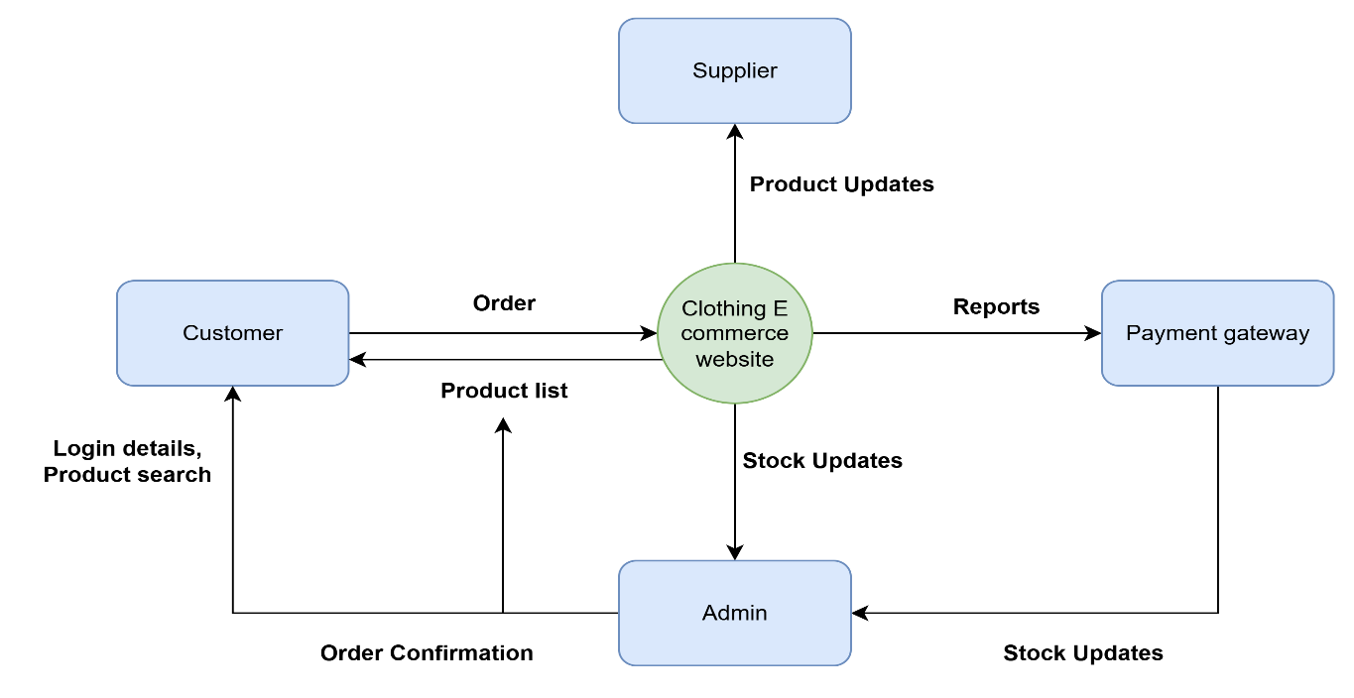 Figure 4: Zero Level DFD Diagram

11. First level DFD Diagram :
Breaks into:

Process 1: User Authentication
- Register
- Login
- Validate user

Process 2: Product Management
- Add product
- Update product
- Display product

Process 3: Cart & Orders
- Add to cart
- Checkout
- Place order

Process 4: Inventory Management
- Update stock
- Manage availability

Process 5: Payment System
- Payment request → Gateway
- Success / failure response

Data Stores:
- Customer DB
- Product DB
- Order DB
- Payment DB
- Inventory DB

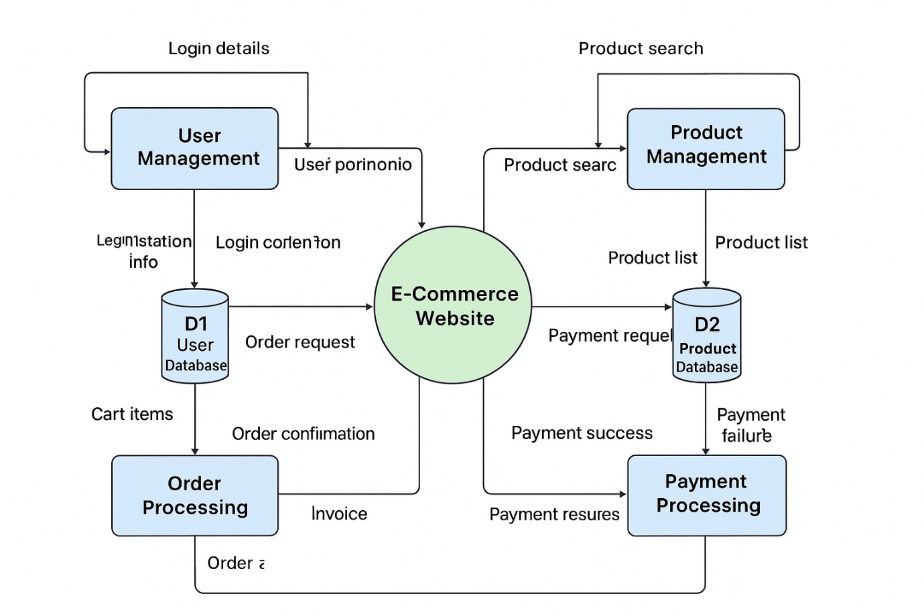
Figure 5: First level DFD Diagram

12. ER Diagram :
The Entity–Relationship (ER) Diagram represents the core data structure of the Clothing E-Commerce Platform. It identifies all essential entities involved in the system and the relationships between them. The purpose of this ERD is to model how customers interact with products, carts, orders, and the administrative panel while ensuring smooth online shopping and efficient store management.

Entities of the ER Diagram
- Customer
- Admin
- Product
- Category
- Cart
- Cart Item
- Order
- Order Item
- Payment
- Review
- Product Image

Relationships
- Customer → Cart
One-to-One: Each customer has one active cart.
- Customer → Order
One-to-Many: A customer can place multiple orders.
- Customer → Review
One-to-Many: A customer can write several reviews for different products.
- Category → Product
One-to-Many: Each category contains multiple products.
- Product → Cart Item
One-to-Many: A product may appear multiple times in different customers’ carts.
- Cart → Cart Item
One-to-Many: A cart contains many cart items.
- Order → Order Item
One-to-Many: An order contains multiple order items.
- Product → Order Item
One-to-Many: A product can appear in many orders.
- Product → Product Image
One-to-Many: A product can have multiple images.
- Order → Payment
One-to-One: Each order has a single payment record.
- Admin → Product / Admin → Order
One-to-Many: Admin manages many products and processes many orders.

Figure: ER Diagram (Description)
The ER Diagram visually illustrates how customers, admins, products, carts, orders, and payments interact within the system. It shows the logical data flow between entities and how the platform supports browsing, cart handling, checkout, order processing, and administration.

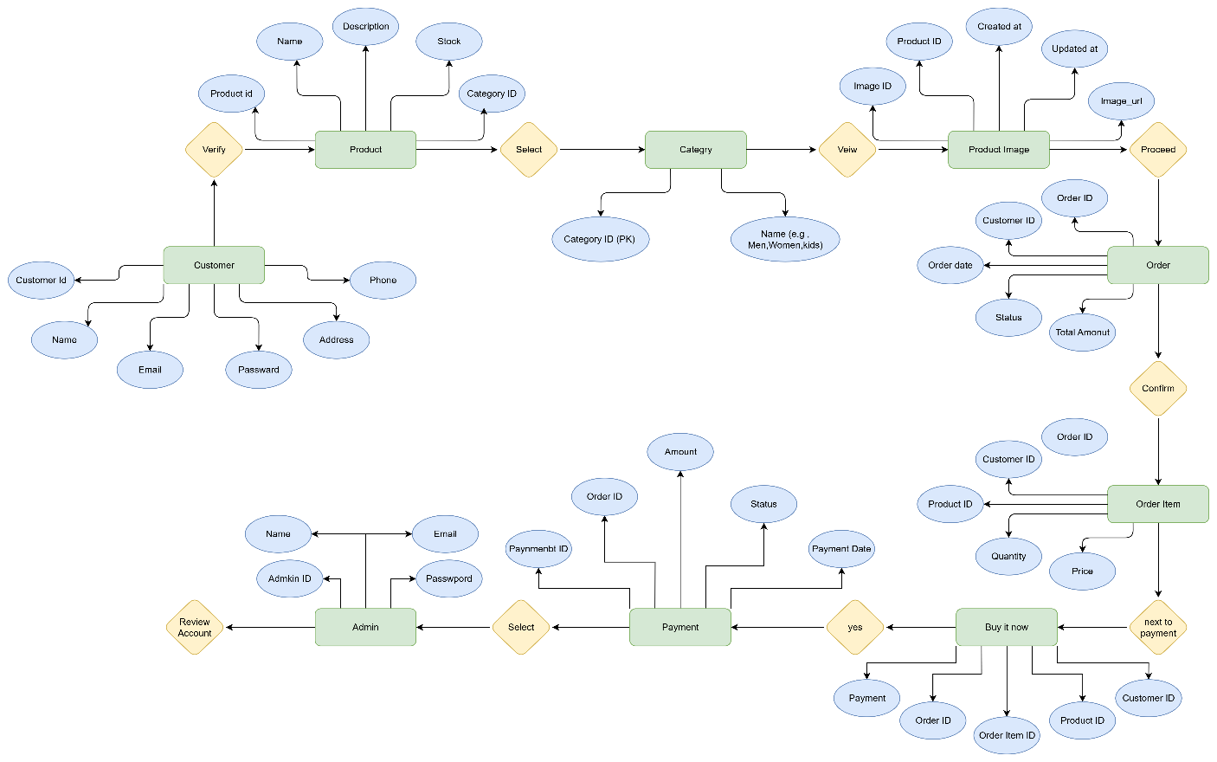

Figure 6: ERD Diagram

13. Use Case Diagram:
Actors: Customer, Admin
Use Cases:Customer
- Login/Signup
- View Product
- Add to Cart
- Payment
- Account management
- Review

Use Cases:Admin:
- Manage product
- Manage order
- Manage users
- Generate reports
- Discounts
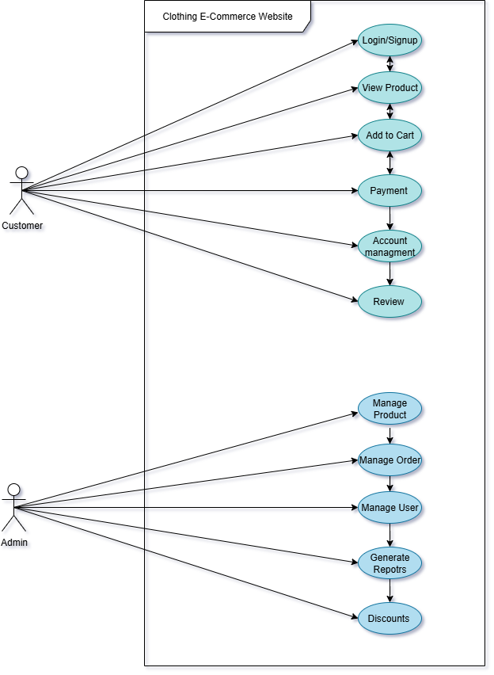
Figure 7: Use Case Diagram

14. Gantt Chart
Timeline from Nov 2024 – May 2025 covering:
- Planning
- Design
- Development
- Testing
- Deployment

Activity | Year: 2024-2025
 | November |  |  | December |  | January |  | February |  | March- May
 | 1st-2nd Week | 3rd-4th Week | 1st-2nd Week |  | 3rd-4th Week | 1st-2nd Week | 3rd-4th Week | 1st-2nd Week | 3rd-4th Week | 1st-2nd Week | 3rd-4th Week | 1st-2nd Week | 3rd-4th Week
Project Planning & Requirements
Design Phase
Development Phase
Testing Phase
Presentation
Evaluation & Rectification

Figure 8: Gantt Chart

15. References
• MERN Documentation (MongoDB, Express.js, React, Node.js)

• Tailwind CSS Documentation

• Cloudinary Documentation

• MongoDB Atlas Documentation

• Vercel Deployment Guides

• Netlify Deployment Guides

• React + Vite Documentation

• Tailwind CSS Docs (Official)

